# LPL Portal Update (Skipton)

Information of Server and Login Credential and Process -

**Bot Development Server -**

**Skipton URL - https://skipton.tmconnect.co.uk/Account/Login**

**Skipton Username - S16276**

**Skipton Password - Password2@**

**Hoowla URL –**

**Hoowla Username-**

**Hoowla Password –**

**PDD Made By: Ravi Rawal**

1. Login to hoowla website.

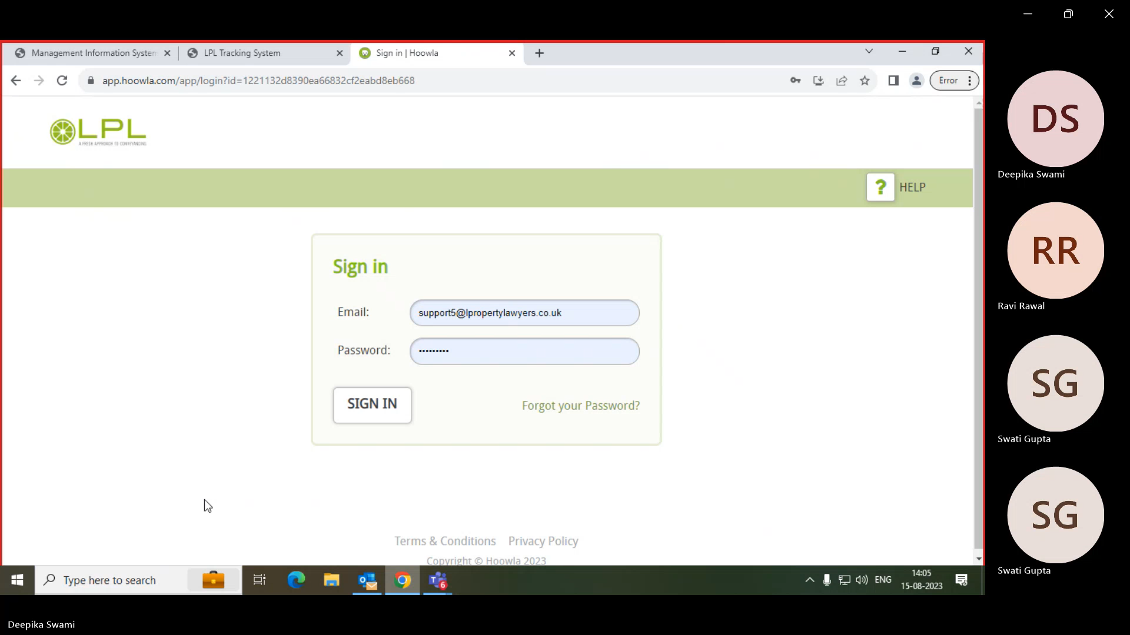

1. Login to Skipton website.

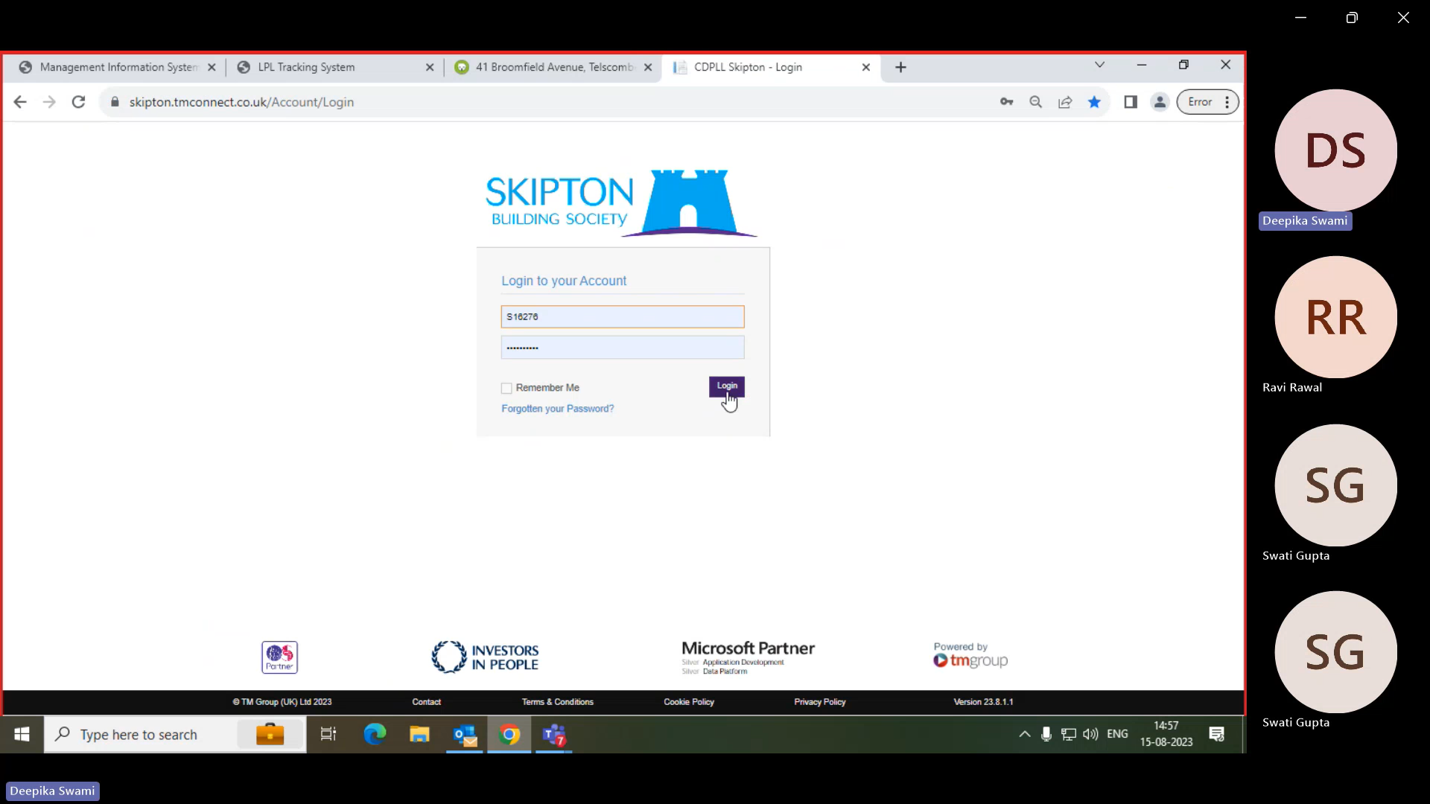

1. Search for Case references and click on view.

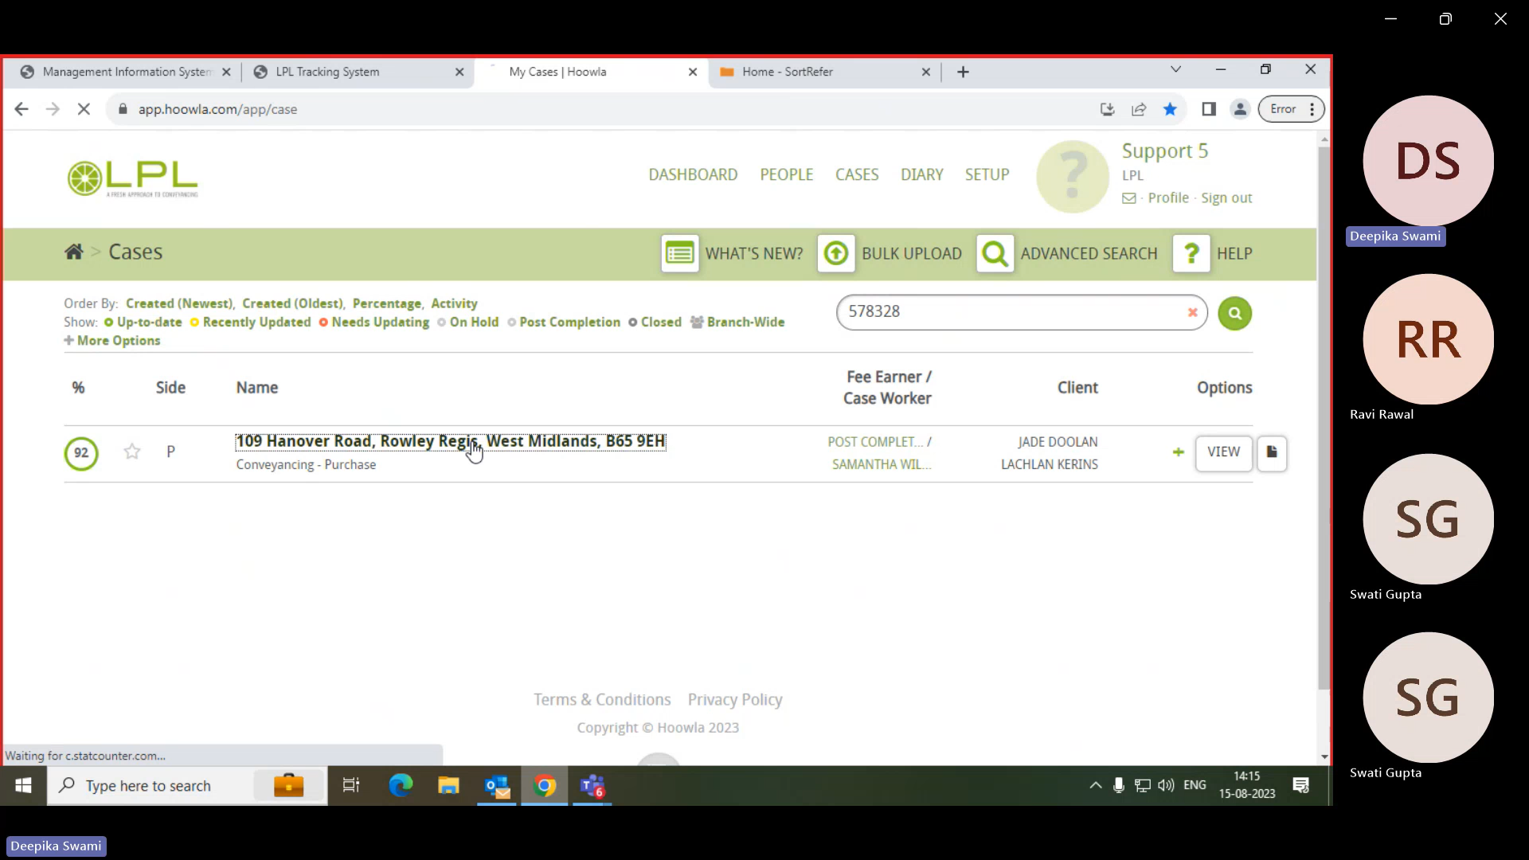

1. Extract the Property Address.



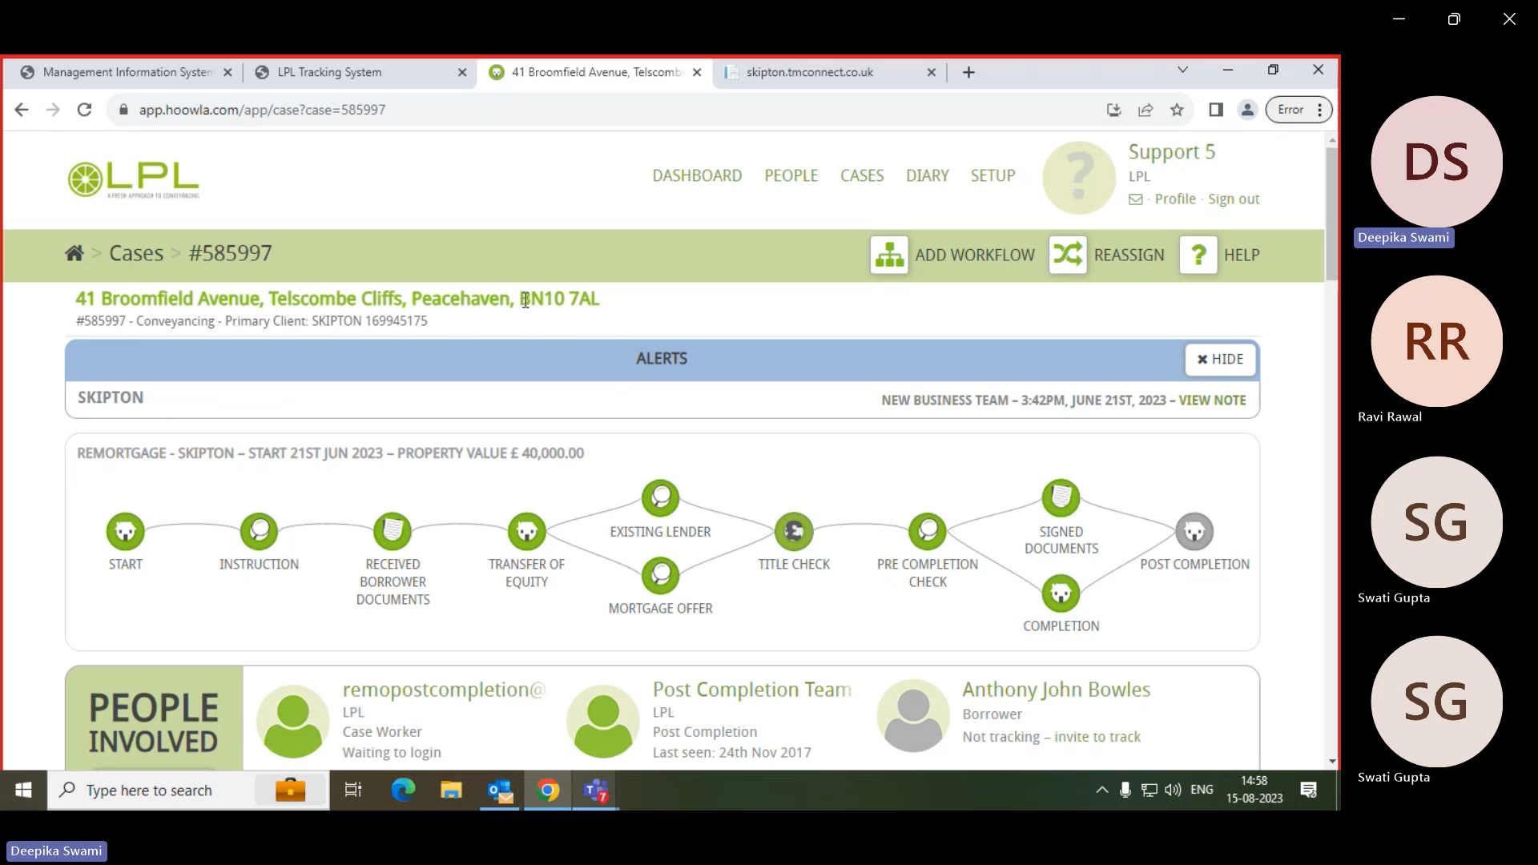



1. Extract the Completion Date and Address.

(Condition – If the completion date provided is a date in the future, then bot will encounter an error [Business Exception] in this scenario.)

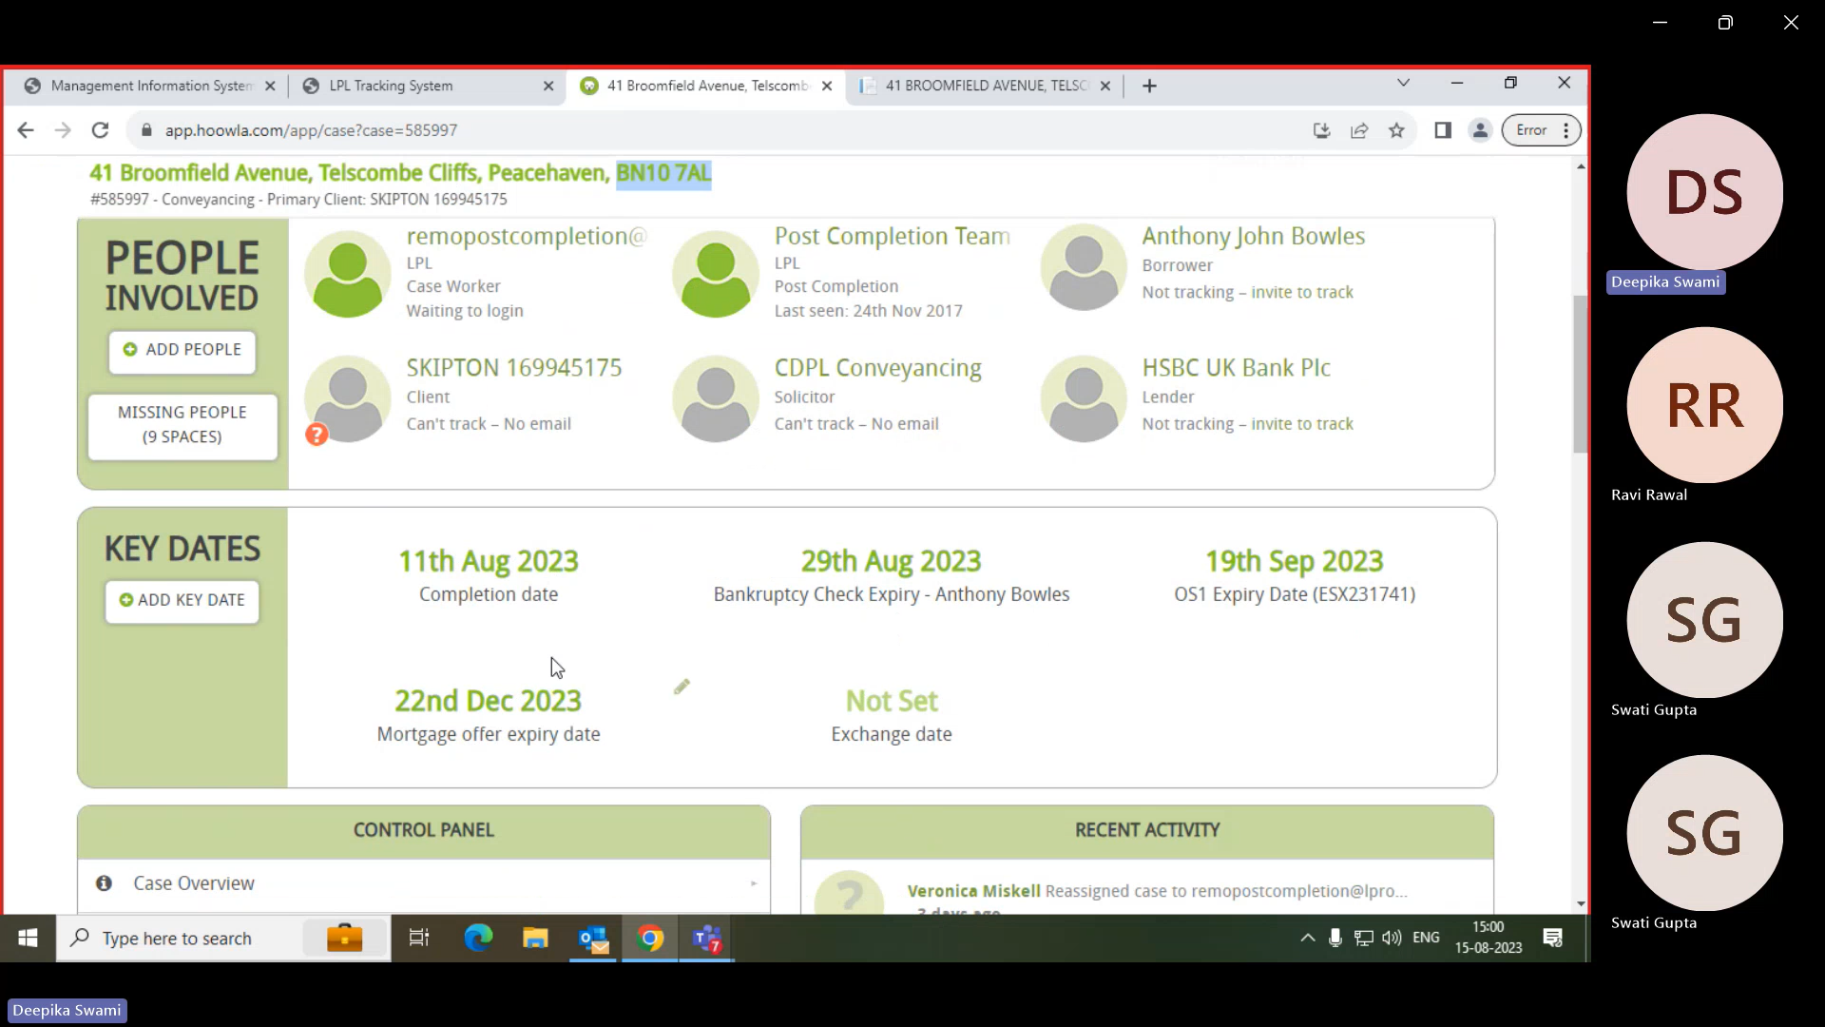

1. Click on all cases.

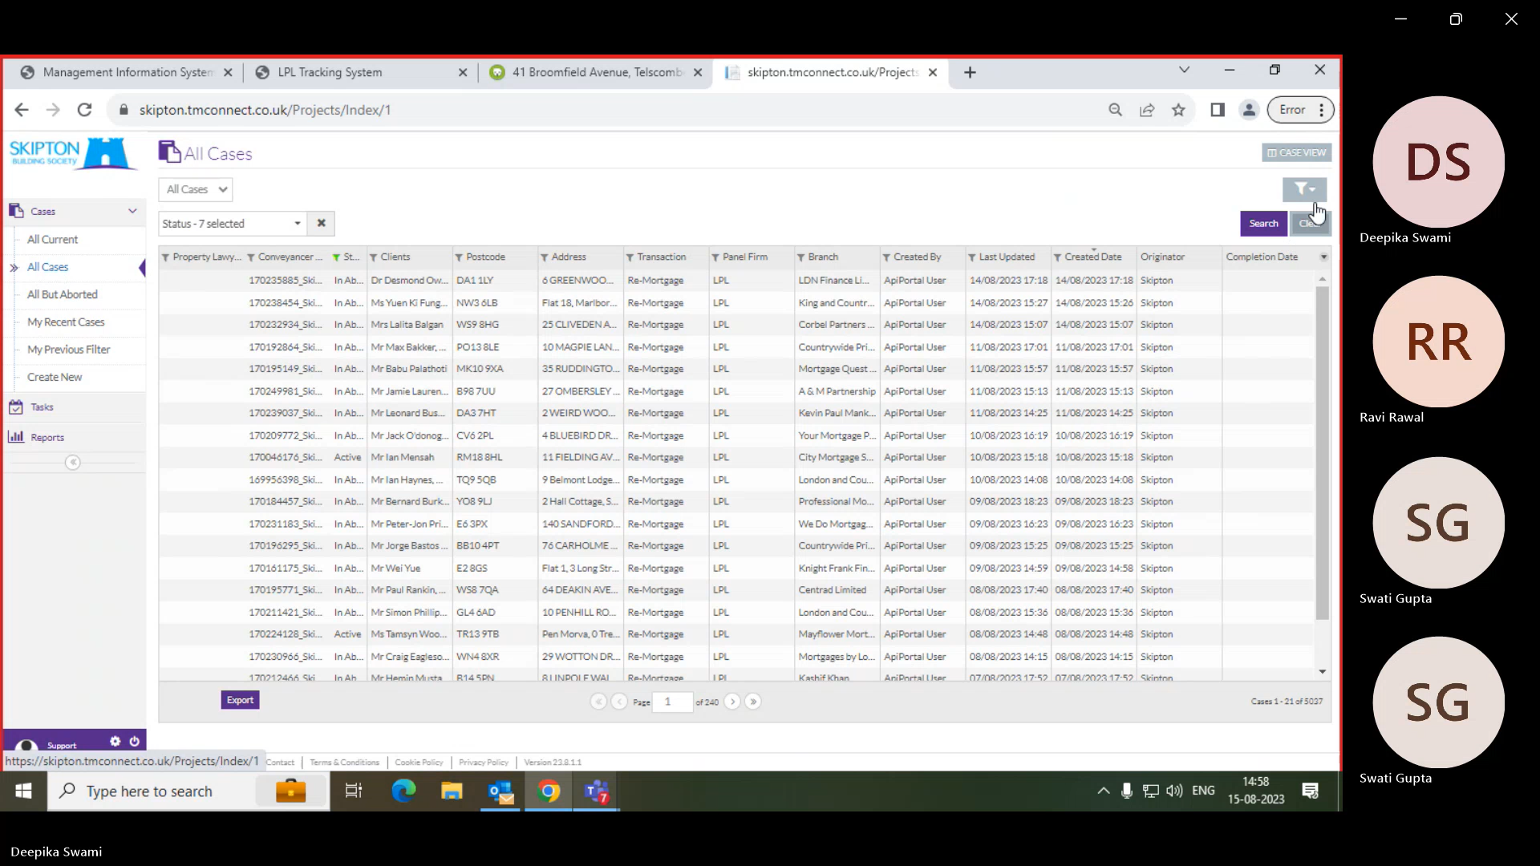

1. Click on Filter and select Postcode option.

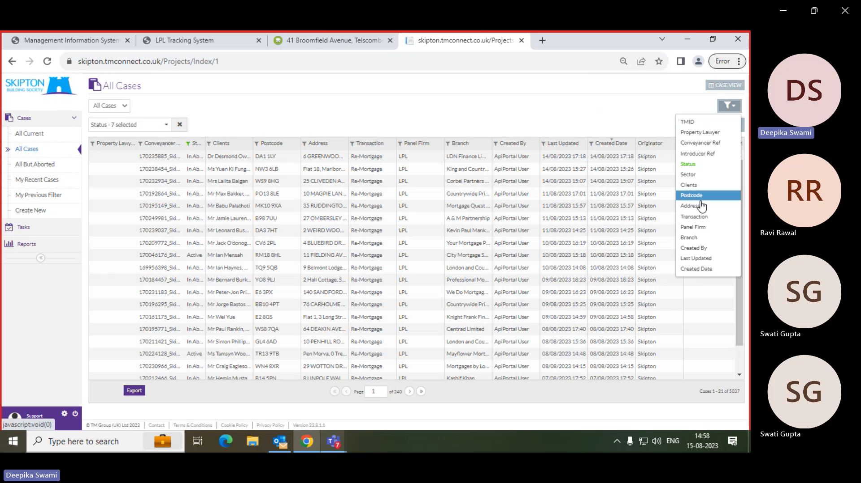

1. Search the case with Postcode.

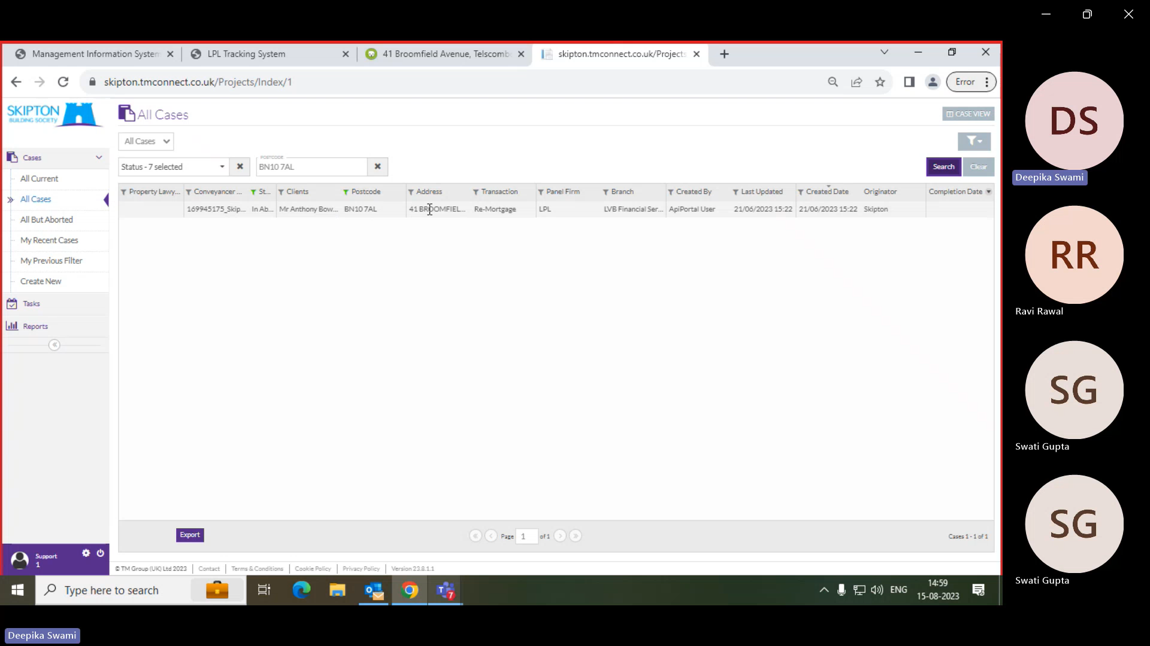

1. Validate the address and postcode then click on the case.

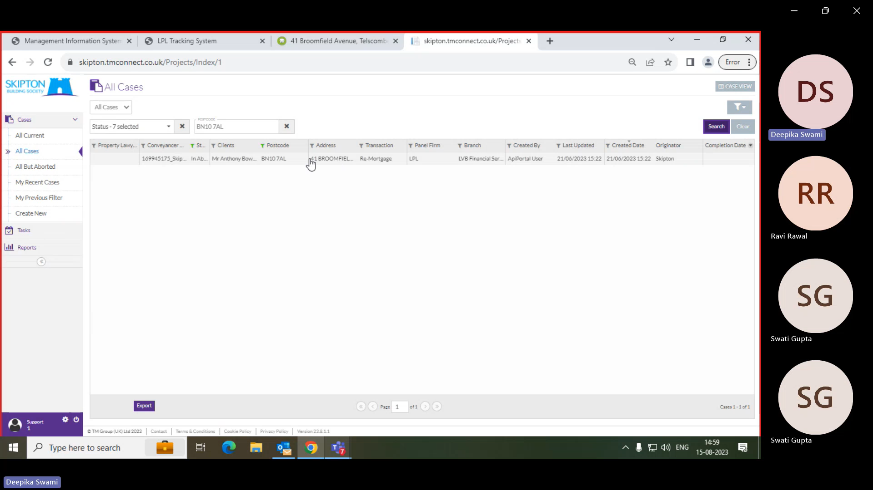

1. Click on milestones.

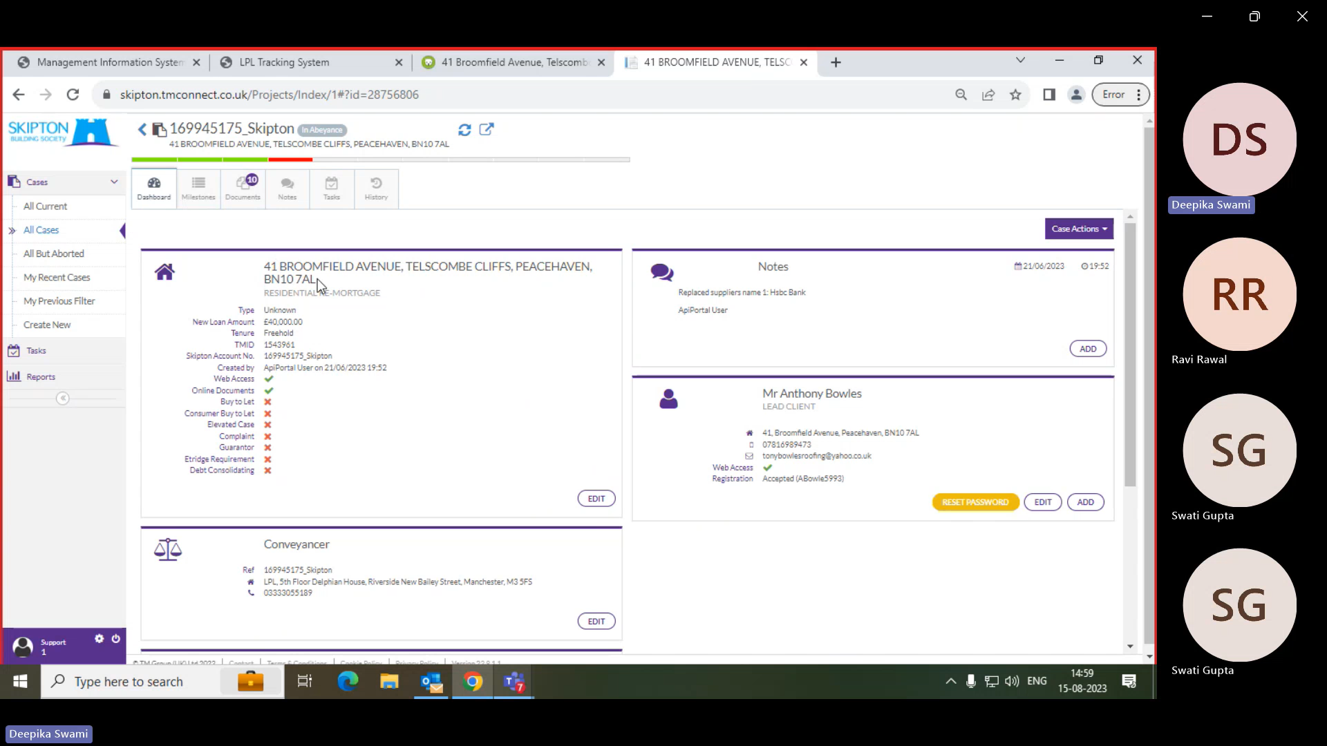

1. Input the completion date in the designated box and ensure the rows above are also appropriately filled.

